DAY-15(3/7/2025)
Emp ID : 110714877
NAME :Kinnera venkatamma

Task 1:

Create a node for a tree and include a constructor (empty)
A node which consists of 1 data part and 2 refs ( 1 Left ref and another right ref)

Solution:

class TreeNode {
int value;
TreeNode left, right;

TreeNode(int item) {
value = item;
left = right = null;
}
}

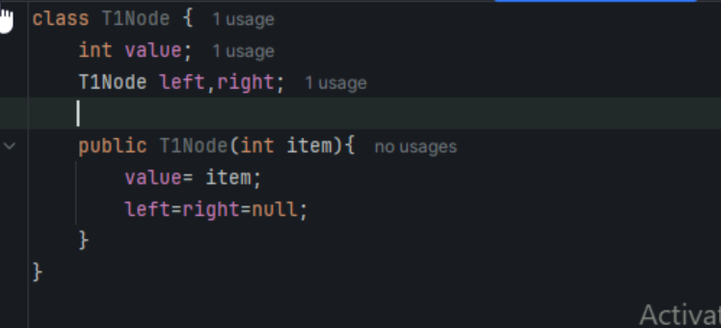

Task 2:

Create a class named Binary Search tree in which you have 2 insert operations

1 insert —----> for inserting if the tree is empty
1 insert —----> for inserting if the tree is 1 or more nodes

TreeNode insertVal(TreeNode node, int value) {
if (node == null) {
node = new TreeNode(value);
return node;
}
if (value < node.value) {
node.left = insertVal(node.left, value);
} else if (value > node.value) {
node.right = insertVal(node.right, value);
}
return node;
}
Task 3: Ionorder travel of the above code snippets from task 1 and Task 2

Task 4: Create a main method Task 1, 2 and 3

Binary search operations-insert, travers, delete, search all performed in 1 program
Solution for Task 1 to task 4
In order Binary Search tree..

class TreeNode {
int value;
TreeNode left, right;

TreeNode(int item) {
value = item;
left = right = null;
}
}
class BinarySearchTreeOp {
TreeNode root;

void insert(int value) {
root = insertVal(root, value);
}
TreeNode insertVal(TreeNode node, int value) {
if (node == null) {
node = new TreeNode(value);
return node;
}
if (value < node.value) {
node.left = insertVal(node.left, value);
} else if (value > node.value) {
node.right = insertVal(node.right, value);
}
return node;
}

void inorder() {
inorderVal(root);
}

void inorderVal(TreeNode node) {
if (node != null) {
inorderVal(node.left);
System.out.print(node.value + " ");
inorderVal(node.right);
}
}
}

public class BinarySearchTree {
public static void main(String[] args) {
BinarySearchTreeOp bstobj = new BinarySearchTreeOp();
bstobj.insert(10);
bstobj.insert(50);
bstobj.insert(40);
bstobj.insert(70);
bstobj.insert(5);
Sytem.out.println("here is the code for in order traversal of Binary search tree ");
bstobj.inorder();
}
}
Task 5: Applications of Trees
Trees find applications in various fields, including file systems, databases, network routing, artificial intelligence, syntax parsing, and more.

They are used to organize and optimize data storage and retrieval, implement efficient searching algorithms, and represent relationships between entities.
Task 6: Create a binary search operation on tree.

Task 7: Solution given to task6

Solution 👍
class TreeNode {
int item;
TreeNode left, right;

TreeNode(int item) {
item = item;
left = right = null;
}
}
class BinarySearchTreeOp02 {
TreeNode root;

public BinarySearchTreeOp02() {
this.root = null;
}

public TreeNode search(int key) {
TreeNode current = root;
while (current != null) { // key 30 current 50 == root
if (key == current.item) {
return current;
} else if (key < current.item) { // key 80 current 50 == root
current = current.left;
} else {
current = current.right;
}
}
return null;
}
}

Task 8:Types of binary trees:

full/strictly :
every node in the tree is either a leaf node(O)/internal node (2 child exactly)

complete/perfect :
all levels completely filled ,are as far left as possible

almost complete binary tree :
It’s a binary tree where all internal nodes (non-leaf nodes) have two children, and any missing nodes in the last level are on the right side.

skewed binary tree :
Also known as a degenerate or pathological tree, is a type of binary tree where every non-leaf node has only one child.

This characteristic results in the tree resembling a linked list rather than a balanced tree structure.

rooted binary tree :
Is a tree data structure where each node has at most two children (left and right) and one node is designated as the root.
Task9 . Applications of Graphs

1. Social Networks
2. Transportation Systems
3. Computer Science
4. Operating Systems
5. World Wide Web
6. Artificial Intelligence and Machine Learning
7. Circuit Design
They are particularly useful in representing networks, analyzing data, and optimizing processes.

Task 10: Types of Graphs:
In data structures and algorithms, graphs can be classified into several types based on their properties.

These include directed vs. undirected, weighted vs. unweighted, simple vs. multi, and cyclic vs. acyclic graphs.

-Wap to display a graph edges .in the below order no od edges 8 and no of vertex 5

Hint:

Class Graph{

Class Edge{
Int start/src;
Int end/dest;
}

Int vertex;
Int edge;

}

Solution:

class Graph01 {
class Edge {
int src, dest;
}
int vertices, edges;

Edge[] edge;

Graph(int vertices, int eges) {
this.vertices = vertices;
this.edges = edges;

edge = new Edge[edges];
for(int i = 0; i < edges; i++) {
edge[i] = new Edge();
}
}

public static void main(String[] args) {
int noVertices = 5;
int noEdges = 8;
Graph gObj = new Graph(noVertices, noEdges);

gObj.edge[0].src = 1;
gObj.edge[0].dest = 2;
gObj.edge[1].src = 1;
gObj.edge[1].dest = 3;
gObj.edge[2].src = 1;
gObj.edge[2].dest = 4;
gObj.edge[3].src = 2;
gObj.edge[3].dest = 4;
gObj.edge[4].src = 2;
gObj.edge[4].dest = 5;
gObj.edge[5].src = 3;
gObj.edge[5].dest = 4;
gObj.edge[6].src = 3;
gObj.edge[6].dest = 5;
gObj.edge[7].src = 4;
gObj.edge[7].dest = 5;

for(int i =0; i < noEdges; i++) {
System.out.println(gObj.edge[i].src+ " - " + gObj.edge[i].dest);
}
}
}
